For my first test I used CURRENT_TIME, this function is used to retrieve the current time from the system clock of the database server. It’s useful for tasks such as recording the current time when inserting or updating records, calculating time differences, or filtering data based on current time conditions.

For the second test, I went trough W3Schools and tested the SELECT MICROSECOND command. This command allows you to extract the microsecond component of a time or datetime value. Its useful for scenarios where you need to work with high precision time data such as measuring exact timing of events or performing calculations that require very fine-grained time resolution.

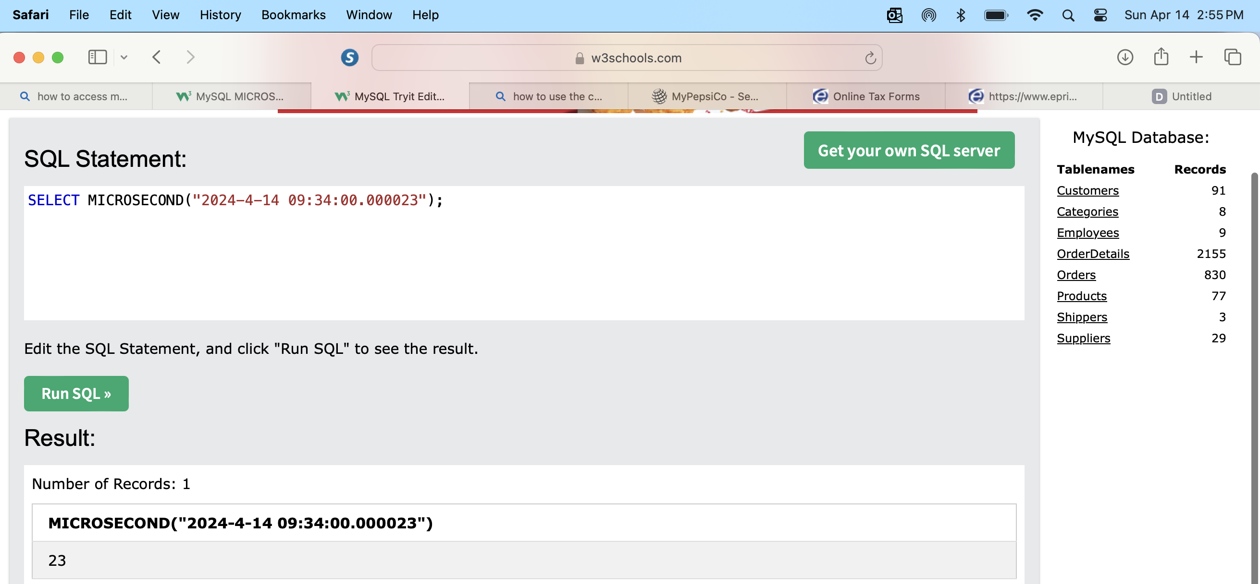

For my 3rd and last test, I went with the SELECT CURRENT_USER command. This command is used to retrieve the current username. It returns the name of the current user as known to the database system. This command is useful for auditing purposes, determining permissions, or customizing query behavior base on the user executing the query. It’s often used in conjunction with other commands or functions to provide user-specific functionality or security measures within a database system.

